**Experiment No.5**

**Program1 :**

// Java Program to sort list of integers

import java.util.Arrays;

public class Expfive

{

public static void main(String[] args)

{

int[] random={33,4,12,56,89,99,13,66,55};

System.out.println("Array before sorting:"+Arrays.toString(random));

Arrays.sort(random);

System.out.println("Array after sorting in ascending order:"+Arrays.toString(random));

}

}

**OUTPUT :**

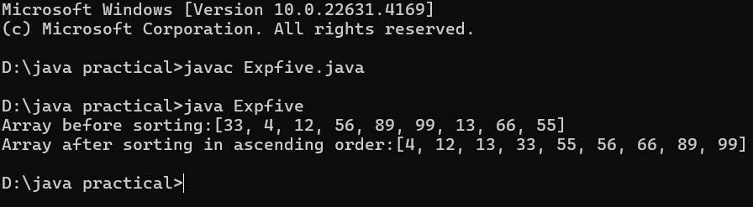

**Program2:**

// Java Program to sort list of Names

import java.util.Arrays;

public class ExpFiveNames

{

public static void main(String[] args)

{

String[] names={"John","Steve","Shane","Adam","Ben"};

System.out.println("String array before sorting:"+Arrays.toString(names));

Arrays.sort(names);

System.out.println("String array after sorting in ascending order:"+Arrays.toString(names));

}

}

**OUTPUT :**

